|  |  |
| --- | --- |
| *school-learn-study-hat-graduate-512.png* | ***Study*** |

**Exercise 1 (No coding required):**

Open your <https://mlab.com> and open the database created for WarmWinter project. Have a look at the id field of each record:

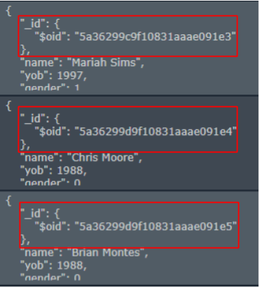

Are there any duplicate ids in the records?

- No, each id is unique

If yes, put screenshots of the records which are so in your answer

If no, why? Guess what information this is field represents and its implication/application

- Because id is the only route to each record

Note: There will be more than one answers and your answers don’t need to be perfect

**Exercise 2:**

Learn how to find a document based on id.

Note: You should copy the id from <https://mlab.com> and put it in your code

For example:

id_to_find = “5a36299d9f10831aaae091e4”

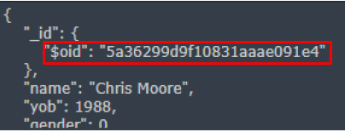

Hint: There are at least two solutions, Google: “*MongoEngine search document by id*”

**Exercice 3:**

Learn how to delete the records found in Exercise 2.

Hint: Google “*Mongoengine delete document*”

|  |  |
| --- | --- |
| *6iporAnbT.jpg* | ***Serious exercises*** |

**Exercise 1:**

Continue with the Warm Winter project you have been discussing from Web Session:

1. Design a new collection named Customer to save the information (name, gender, email, phone number, job, company, contacted...) of all customers using our service.
2. You can craft the information yourself or fake it using Faker.
3. Save the information to the database of Warm Winter project.
4. Render the added data in Flask route /customer
5. Create a link in home page to show 10 first male, not-yet-contacted customers